Library Management System

1.Quick Start user guide:

This Library Management System has 5 main functions:

a) Search for Books:

The user can enter any of the book id, book title and book author of the book wanted. And the system will show a table of the results which includes the book id, title, author, the number of copies and availability in each branch.

Then a check out button will follow every row of the table. Once the user click the button, the system will prompt to enter card number to check out. If the card number has three books haven’t returned, the check out will be reject.

b) Sign up:

The user can use this function to create a new account to borrow books. The user need to enter his full name, address and phone. If the full name and address are all same with one existed account, the register will be reject.

c) Check in book:

This part offers a function to check in books. The user can enter any of book id, card number or customer’s full name to get the loan information. Then the system will display a table of the records and the user can choose one to check in. Once check in completes, the return date of the book will be updated.

d) Update fines:

The system also provides a function to update the late fee of every loan records.

e) Pay fines:

If the user wants to pay its late fee, he can use his card number to check his late records. Once enter the card number, the whole late fee of this customer will be displayed and the user can pay the fee by click a button. If the customer still has overdue books that need to return , the execution of pay will be reject.

2. High-level architecture, design decisions, and justifications:

The database of the library management system has 7 tables: BOOK, BOOK_AUTHORS, BOOK_COPIES, BOOK_LOANS, BORROWER, FINES and LIBRARY_BRANCH.

The BOOK which contains the information of book title. It contains the book id ( primary key) and title.

The BOOK_AUTHORS contains the information of book author. It the book id (foreign key of the BOOK) and author.

The BOOK_COPIES contains the information of book copies in every library branch. It contains the book id (foreign key of the BOOK) , branch id (foreign key of LIBRARY_BRANCH), and the number of copies in the corresponding library branch.

The BOOK_LOANS contains the information of the loan records. It contains the loan_id, book id (foreign key of the BOOK), branch id (foreign key of the LIBRARY_BRANCH), card number (foreign key of the BORROWER), date out, date in and due date.

The BORROWER contains the information of the borrower. It contains the card number, full name, address and phone number.

The FINES contains the late fee information. It contains the loan id (foreign key of the BOOK_LOANS), fine amount and a Boolean value that indicate whether the fee has been paid.

The LIBRARY_BRANCH contains the information of the library branch. It contains the branch id, branch name and branch address.

The structure is like below:

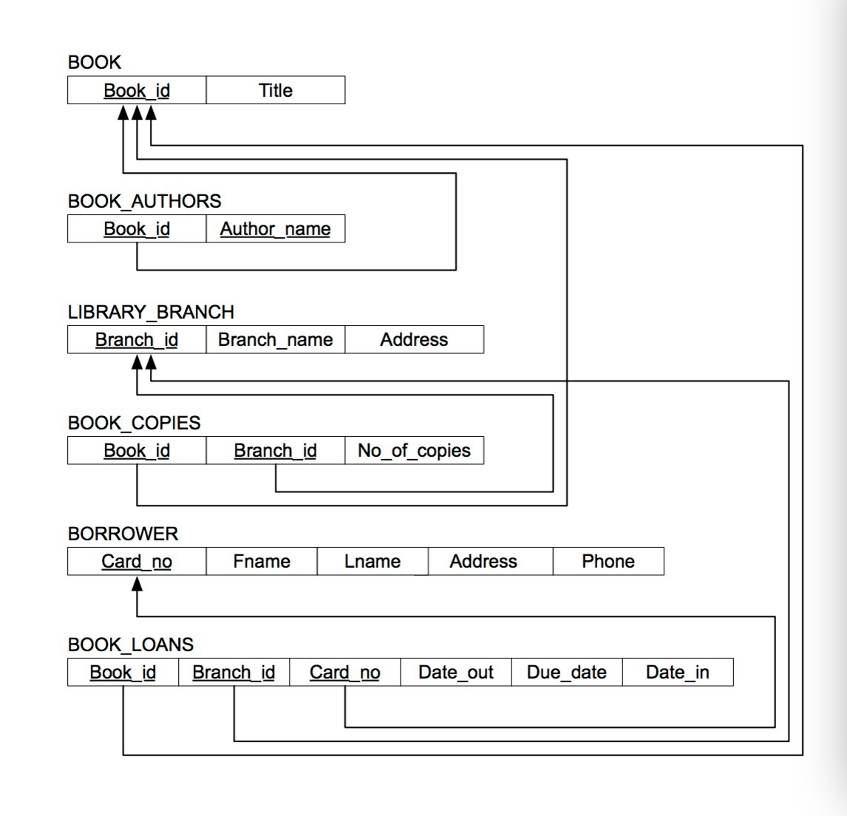

3. Technical dependencies and build instructions.

-- MAMP version 3.4

-- MySQL version 5.6.26

-- MySQL dump 10.13 Distrib 5.6.24, for osx10.8 (x86_64) -- Host: localhost Database: library

-- Server version 5.5.42

-- html, css, php editor : TextWrangle